6.23: a) On the way up, gravity is opposed to the direction of motion, and so .
b) 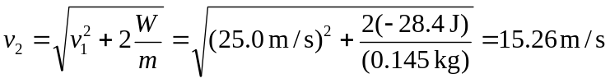.
c) No; in the absence of air resistance, the ball will have the same speed on the way down as on the way up. On the way down, gravity will have done both negative and positive work on the ball, but the net work will be the same.

